**Title: From Siri to Smarty pants: Building Your Personalized AI Assistant**

In today's technological landscape, digital assistants like Siri have become integral parts of our daily routines. However, these mainstream offerings often lack the personalization necessary to truly meet individual needs. This abstract explores the concept of building a personalized AI assistant, surpassing the limitations of existing solutions to deliver a tailored experience.

The journey begins with the acknowledgment that one-size-fits-all approaches no longer suffice. Personalized AI assistants must adapt and evolve alongside their users. Leveraging sophisticated machine learning algorithms, these assistants analyze user behavior, preferences, and contextual cues to anticipate and fulfill unique needs. Additionally, users are empowered to customize their assistants, fine-tuning capabilities and interactions to align with specific requirements.

Central to this endeavor is the integration of advanced natural language processing (NLP) capabilities. Unlike traditional assistants, personalized AI assistants excel at interpreting and responding to natural language inputs. Through cutting-edge NLP models trained on vast datasets, they recognize and understand human language intricacies, fostering fluid and intuitive conversations.

However, the development of personalized AI assistants poses challenges and ethical considerations. Data privacy, security, and algorithmic bias are paramount concerns. Robust privacy measures must be implemented to safeguard user data, while efforts to address algorithmic biases ensure inclusivity and equity.

In conclusion, building a personalized AI assistant represents a paradigm shift in digital assistance. By prioritizing customization, integration, and empowerment, developers can create assistants that resonate with users on a personal level. Leveraging machine learning and advanced NLP, these assistants evolve beyond tools into trusted companions. Moreover, by navigating ethical and technical challenges, developers pave the way for a future where AI assistants enhance daily life while upholding privacy and fairness principles.

**2. SYSTEM REQUIREMENTS:**

**2.1 HARDWARE REQUIREMENTS**

1. High-performance computing hardware (e.g., multi-core CPU, GPU, or specialized AI accelerators like TPUs) for training and inference tasks.

2. RAM-4 GB or higher

3.SSD storage for access and retrieval.

4.Internet connectivity

**2.2 SOFTWARE REQUIREMENTS**

1. Operating System- Windows, Linux, or macOS.

2. Development Environment- Integrated Development Environment (IDE) such as PyCharm, Visual Studio Code, or Jupyter Notebook.

3.Programming Languages: Proficiency in languages such as Python, Java, or C++ for AI development.

4. Text-to-Speech (TTS) Libraries: Libraries like pyttsx3 for generating speech output.

**2.3 TOOLS AND VERSIONS:**

1.Python (Programming Language): Python 3.x (Latest stable release recommended)

2.TensorFlow: Version 2.x

3.PyTorch: Version 1.10

4.NLTK (Natural Language Toolkit): Version 3.x

5.Speech Recognition: Version 3.x

**TimeLine**

**1. Research and Planning (1 month):**

• Define project scope, objectives, and target audience.

• Conduct market research on existing AI assistants and personalized services.

• Analyze technologies and algorithms for personalized AI assistant development.

**2. Data Collection and Analysis (2 months):**

• Set up data collection mechanisms for user interactions and preferences.

• Analyze collected data to identify patterns and user preferences.

• Define parameters for personalization and customization.

**3. Development Phase 1: Infrastructure Setup (1 month):**

• Set up infrastructure for AI assistant development.

• Implement basic functionalities such as user authentication and data storage.

**4. Development Phase 2: Machine Learning and NLP (3 months):**

• Develop machine learning algorithms for user behavior analysis and personalization.

• Implement advanced NLP models for natural language understanding and generation.

• Integrate machine learning and NLP components into the assistant.

**5. Testing and Iteration (2 months):**

• Conduct thorough testing of the personalized AI assistant.

• Gather feedback from beta testers and refine functionalities based on user input.

• Address any bugs or issues identified during testing.

**6. Ethical Considerations and Privacy Measures (1 month):**

• Evaluate and implement robust privacy measures to safeguard user data.

• Address algorithmic biases and ensure inclusivity and fairness in the assistant's responses.

**7. Integration and Customization (2 months):**

• Integrate user customization features, allowing users to fine-tune their assistants.

• Test and refine customization options based on user feedback.

**8. Deployment and Launch (1 month):**

• Prepare marketing materials and documentation for users.

• Deploy the personalized AI assistant to the target audience.

• Monitor performance metrics and gather user feedback post-launch.

**9. Ongoing Maintenance and Updates (continuous):**

• Monitor user interactions and update machine learning models accordingly.

• Release periodic updates to enhance functionality and address user needs.

• Stay informed about advancements in AI technology for potential future improvements.

This timeline spans approximately 14-15 months, allowing for comprehensive development, testing, and refinement of the personalized AI assistant. It accommodates the complexity of the project and ensures that ethical considerations are carefully addressed throughout the development process.

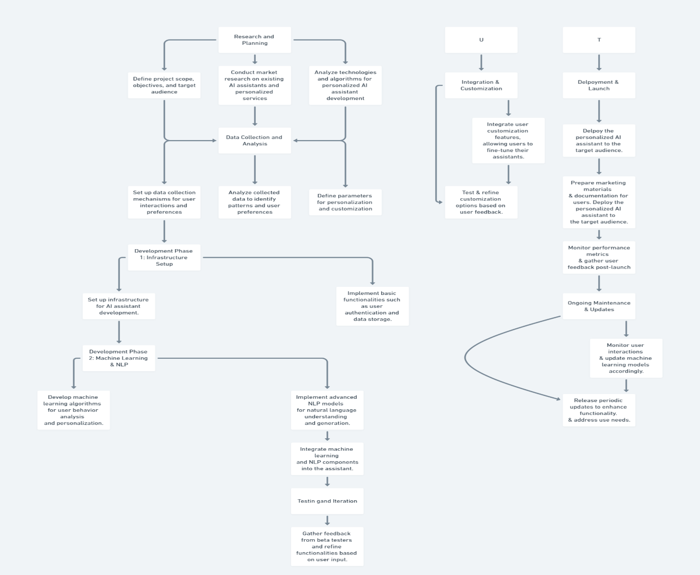

**HURDLES FACED:**

Speech recognition technology may not always accurately transcribe spoken words, especially in noisy environments or with speakers with accents. You may need to implement robust error handling to deal with misinterpreted speech.

Designing a natural and intuitive user interaction flow, especially for voice-based interfaces, can be challenging.

Handling unexpected inputs, errors, and edge cases gracefully is essential for a robust user experience.

Voice-based AI assistants often involve processing sensitive user data, raising privacy and security concerns.

Testing speech-based applications can be challenging due to the variability of human speech and the complexity of natural language processing.

**Flowchart:**

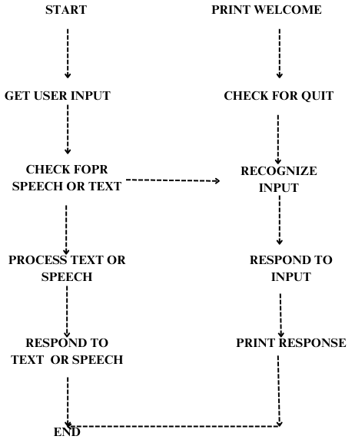

**Program:**

import random

import speech_recognition as sr

# Define some responses

responses = {

"hello": ["Hello!", "Hi there!", "Hey!"],

"how _are_you": ["I'm doing well, thank you!", "I'm good, thanks for asking.", "All good on this side."],

"bye": ["Goodbye!", "See you later!", "Bye! Take care."],

"random": ["Interesting!", "Tell me more.", "I see.", "Fascinating!"]

}

def greet ():

return random. Choice (responses["hello"])

def ask_how_are_you ():

return random. Choice (responses["how_are_you"])

def say_goodbye ():

return random. Choice (responses["bye"])

def respond_to_input(input_text):

if "hello" in input_text. Lower ():

return greet ()

elif "how are you" in input_text. Lower ():

return ask_how_are_you ()

elif "bye" in input_text. Lower ():

return say_goodbye ()

else:

return random. Choice (responses["random"])

def recognize_speech ():

recognizer = sr. Recognizer ()

with sr. Microphone () as source:

print("Listening...")

recognizer. adjust_for_ambient_noise (source, duration=1)

audio = recognizer.listen(source)

try:

print("Recognizing...")

text = recognizer.recognize_google(audio)

print("You said:", text)

return text

except sr.UnknownValueError:

print("Sorry, I couldn't understand what you said.")

return ""

except sr.RequestError as e:

print("Could not request results from Google Speech Recognition service; {0}".format(e))

return ""

def main():

print("Welcome to Smartypants! Say something or type 'quit' to exit.")

while True:

user_input = input("> ")

if user_input.lower() == 'quit':

print(say_goodbye())

break

else:

if user_input.strip() == "":

user_input = recognize_speech()

response = respond_to_input(user_input)

print(response)

if __name__ == "__main__":

main()

**OUTPUTS**:

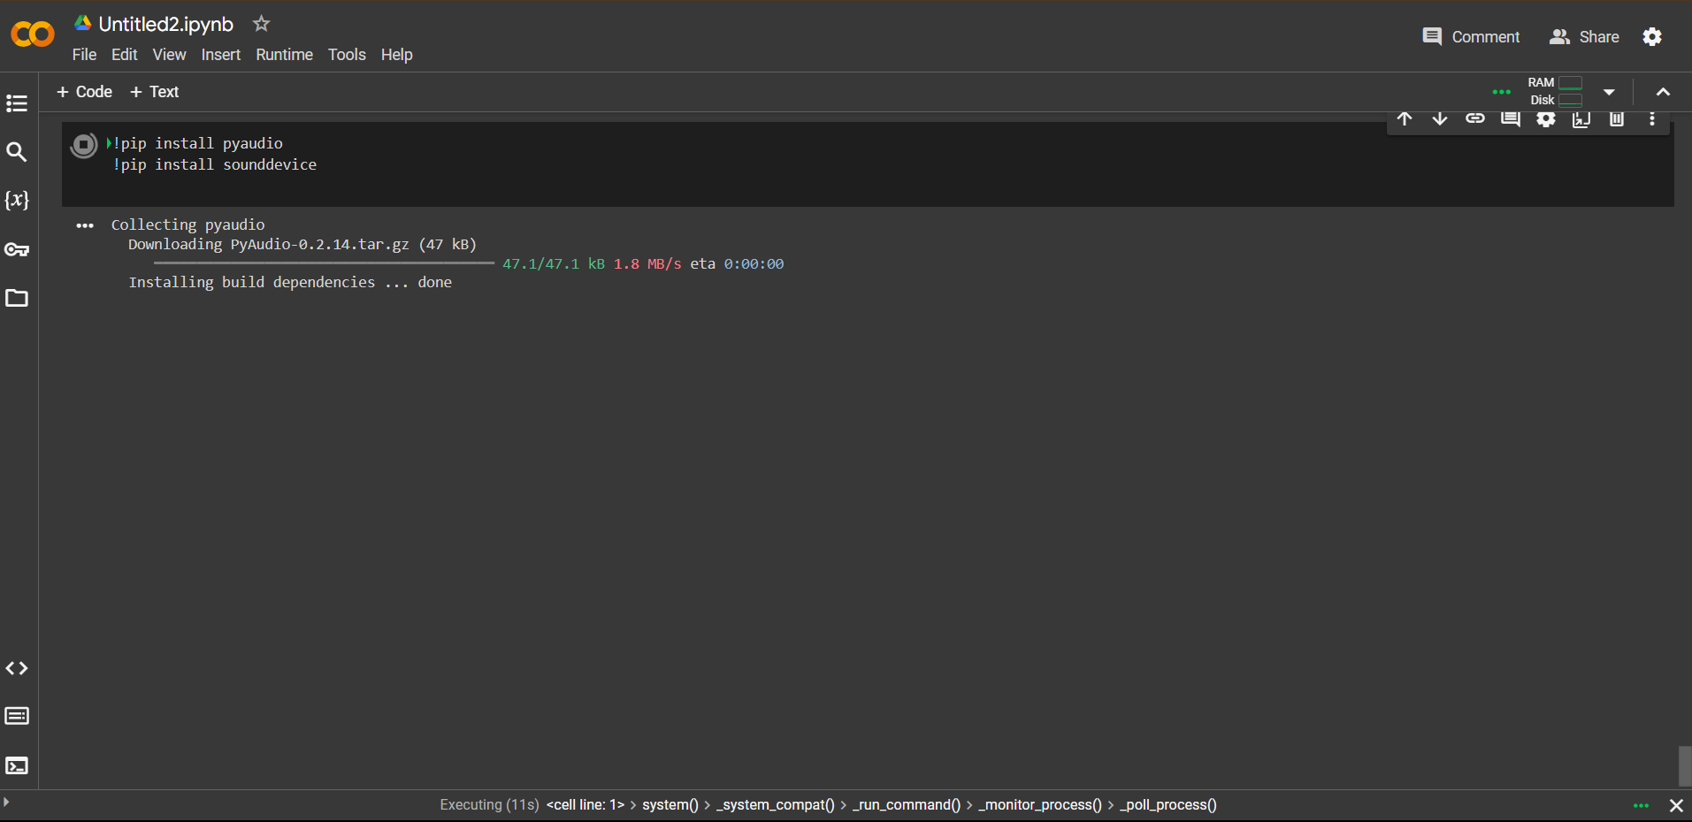

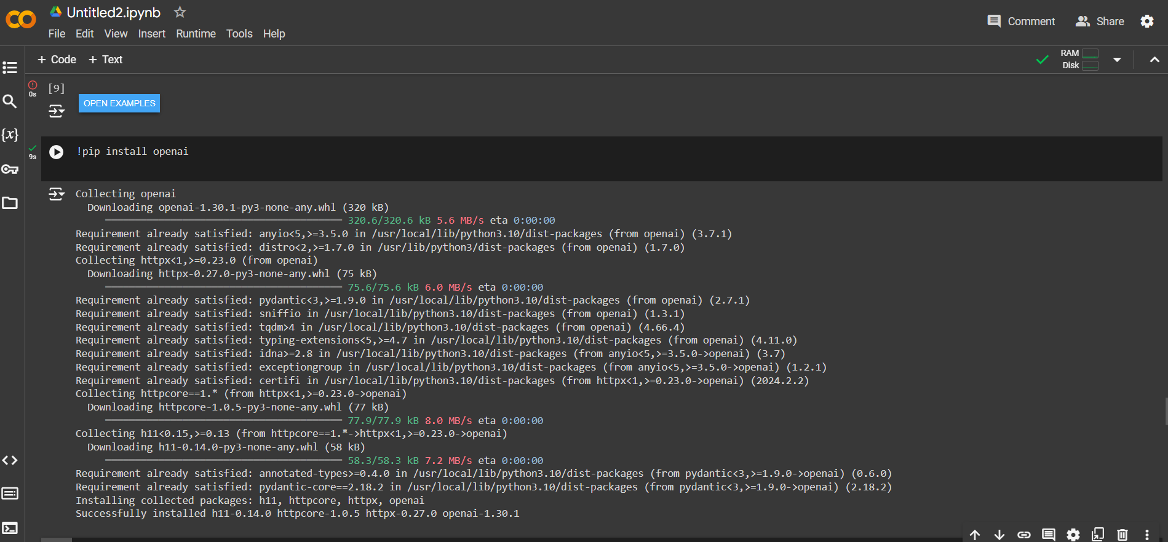

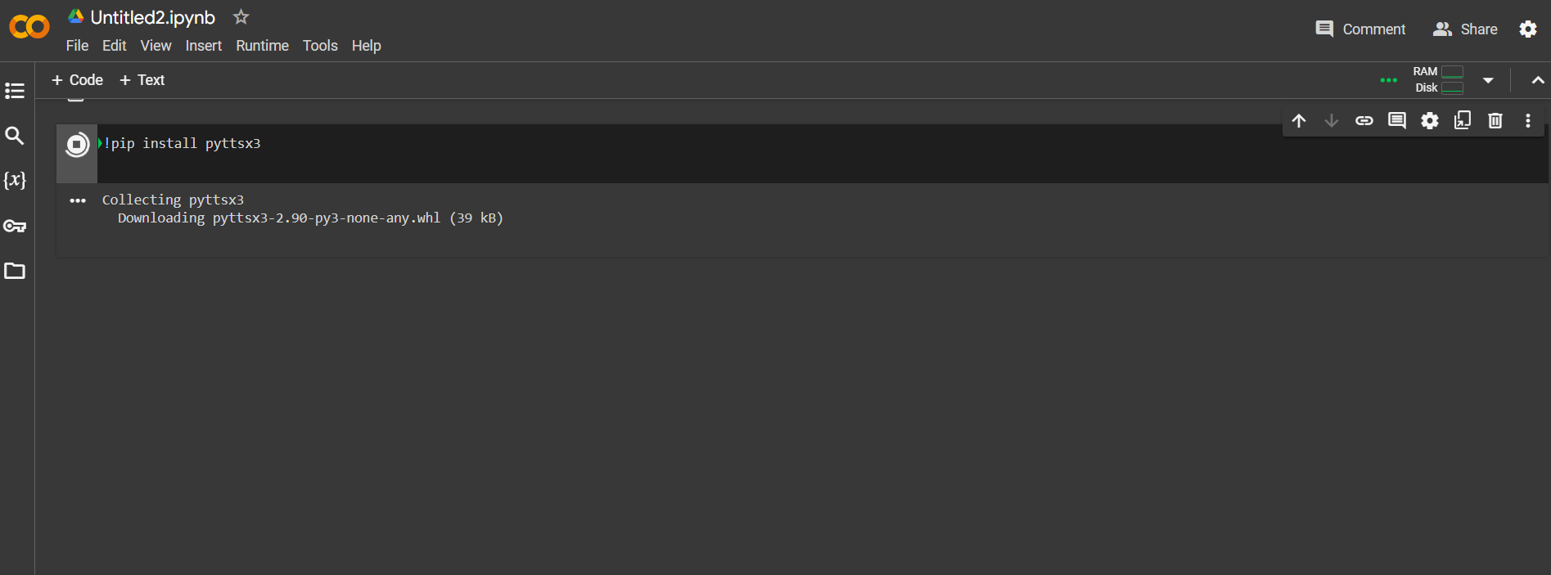

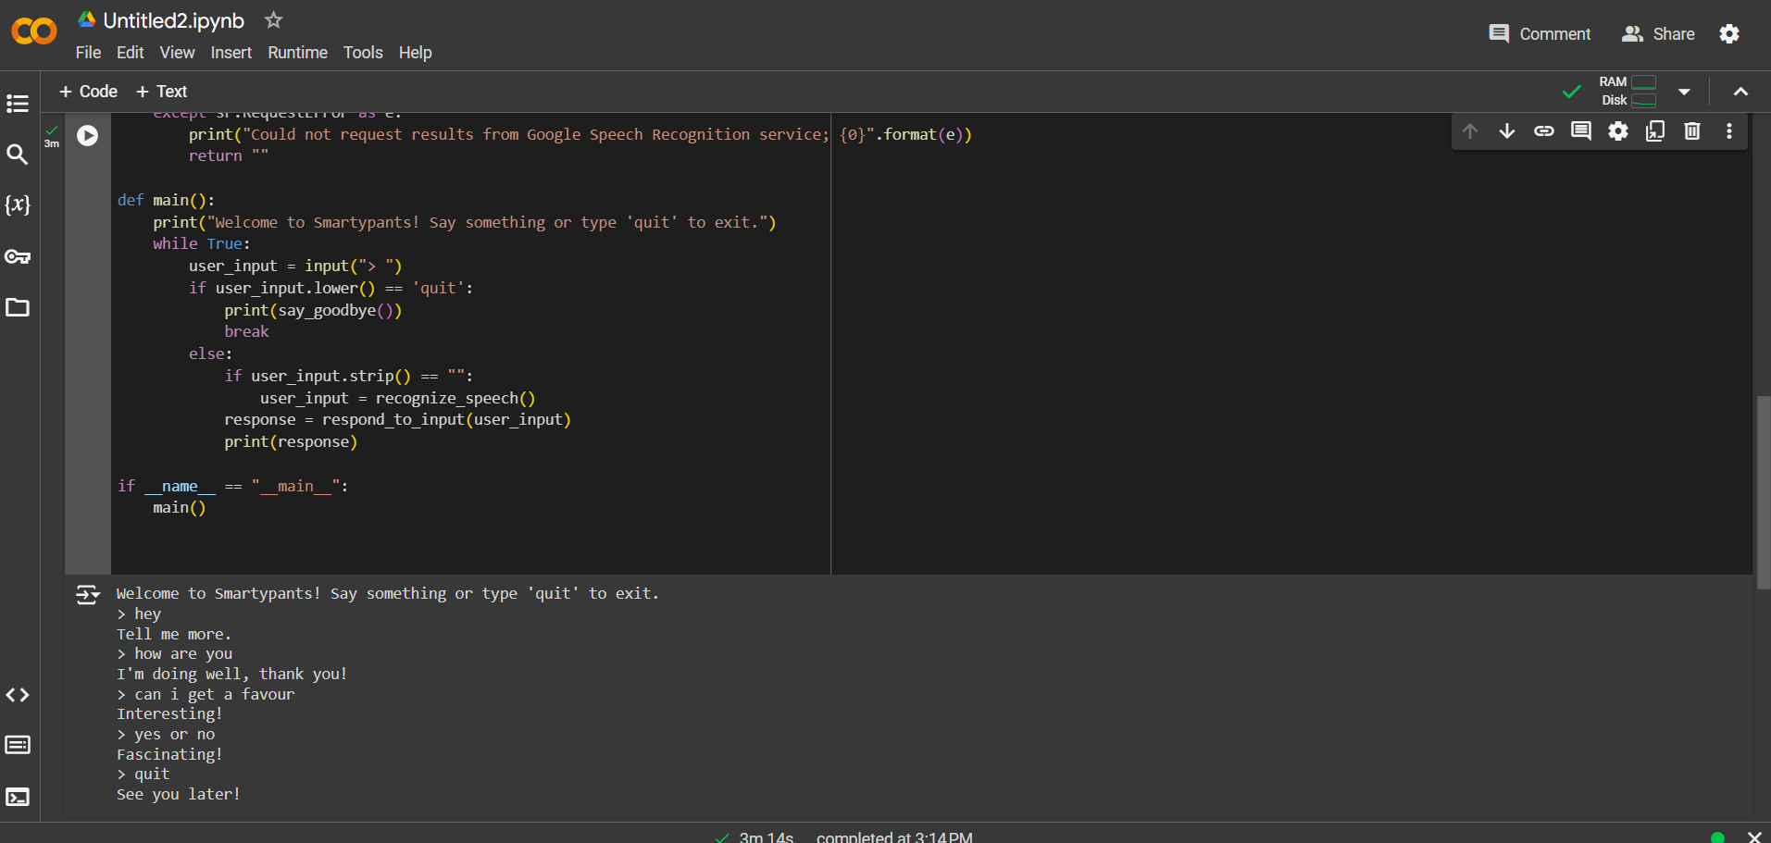

**CONCLUSION AND FUTURE SCOPE:**

Building personalized AI assistants marks a significant advancement in digital assistance by focusing on user-specific customization and integration. These assistants, powered by sophisticated machine learning algorithms and advanced natural language processing (NLP), transcend the role of simple tools, evolving into trusted companions that seamlessly fit into users' lives.

The core of this evolution lies in the ability of personalized AI assistants to adapt and evolve in tandem with their users. By analysing user behaviour, preferences, and contextual cues, these assistants can anticipate and fulfil unique needs, delivering a tailored experience that mainstream offerings cannot match. Users are further empowered by the ability to customize their assistants, fine-tuning capabilities and interactions to align with their specific requirements.

However, the development of personalized AI assistants is not without its challenges. Data privacy and security are paramount concerns, requiring robust measures to safeguard user information. Additionally, addressing algorithmic bias is crucial to ensure inclusivity and equity in AI interactions. Developers must implement transparent, fair, and accountable practices to build trust and ensure that these assistants provide equal utility to all users, regardless of their background.

In conclusion, the shift towards personalized AI assistants represents a new era in digital assistance. By leveraging machine learning and advanced NLP, these assistants can offer more relevant, timely, and intuitive support, enhancing daily life. The future of AI assistance lies in creating systems that not only meet but exceed user expectations, becoming indispensable parts of our daily routines. As developers navigate ethical and technical challenges, they lay the groundwork for AI assistants that uphold principles of privacy and fairness, ultimately enriching users' lives on a personal level.

**Future Scopes:**

1. **Enhanced Personalization Techniques:**

Future developments could see even more sophisticated personalization algorithms, capable of understanding and predicting user needs with greater accuracy. This may involve deeper integration with various aspects of users' digital lives, including social media, health data, and smart home devices.

1. **Improved Contextual Understanding:**

Advancements in context-aware computing will enable AI assistants to better understand the situational context of user interactions. This could lead to more intuitive responses and proactive assistance based on real-time environmental and contextual data.

1. **Cross-Platform Integration:**

AI assistants of the future will likely be seamlessly integrated across multiple platforms and devices, providing a unified experience. This includes not only smartphones and computers but also wearables, smart home devices, and even vehicles.

1. **Emotion Recognition and Response:**

Incorporating emotional intelligence into AI assistants could allow for more empathetic interactions. By recognizing and responding to users' emotional states, AI assistants could provide support that is not only functional but also emotionally resonant.

1. **Enhanced Security and Privacy Measures:**

As personalization deepens, the need for robust security and privacy measures will become even more critical. Future AI assistants will need to employ advanced encryption techniques, decentralized data storage, and transparent user consent protocols to protect user data.

1. **Addressing Algorithmic Bias:**

Continued efforts to understand and mitigate algorithmic biases will be essential. This involves diversifying training data and implementing fairness-aware machine learning techniques to ensure that AI assistants provide equitable support to all users.

1. **Learning and Adaptation:**

Future AI assistants will possess the capability to continuously learn and adapt over time, refining their performance based on ongoing user interactions and feedback. This dynamic learning process will enhance their ability to meet evolving user needs.

1. **Multilingual and Cultural Adaptation:**

Expanding the linguistic and cultural adaptability of AI assistants will make them more accessible and useful to a global audience. This includes supporting multiple languages, dialects, and culturally specific norms and preferences.

By exploring these future scopes, developers can push the boundaries of what personalized AI assistants can achieve, ultimately transforming the way we interact with technology and enhancing the overall quality of our daily lives.